**NAME: roshni raza**

**SAP ID: 59013**

**COURSE: COAL**

**LAB: 9**

**TASK: 1**

.model small

.stack 100h

.data

msg1 db 10,13, "Enter first number: $"

msg2 db 10,13, "Enter second number: $"

msg3 db 10,13, "Numbers are equal$"

msg4 db 10,13, "Numbers are not equal$"

.code

main proc

mov ax, @data

mov ds, ax

mov dx, offset msg1

mov ah, 9

int 21h

mov ah, 1

int 21h

mov cl, al

mov dx, offset msg2

mov ah, 9

int 21h

mov ah, 1

int 21h

mov dl, al

cmp cl, dl

je equal

mov dx, offset msg4

mov ah, 9

int 21h

jmp exit

equal:

mov dx, offset msg3

mov ah, 9

int 21h

exit:

mov ah, 4Ch

int 21h

main endp

end main

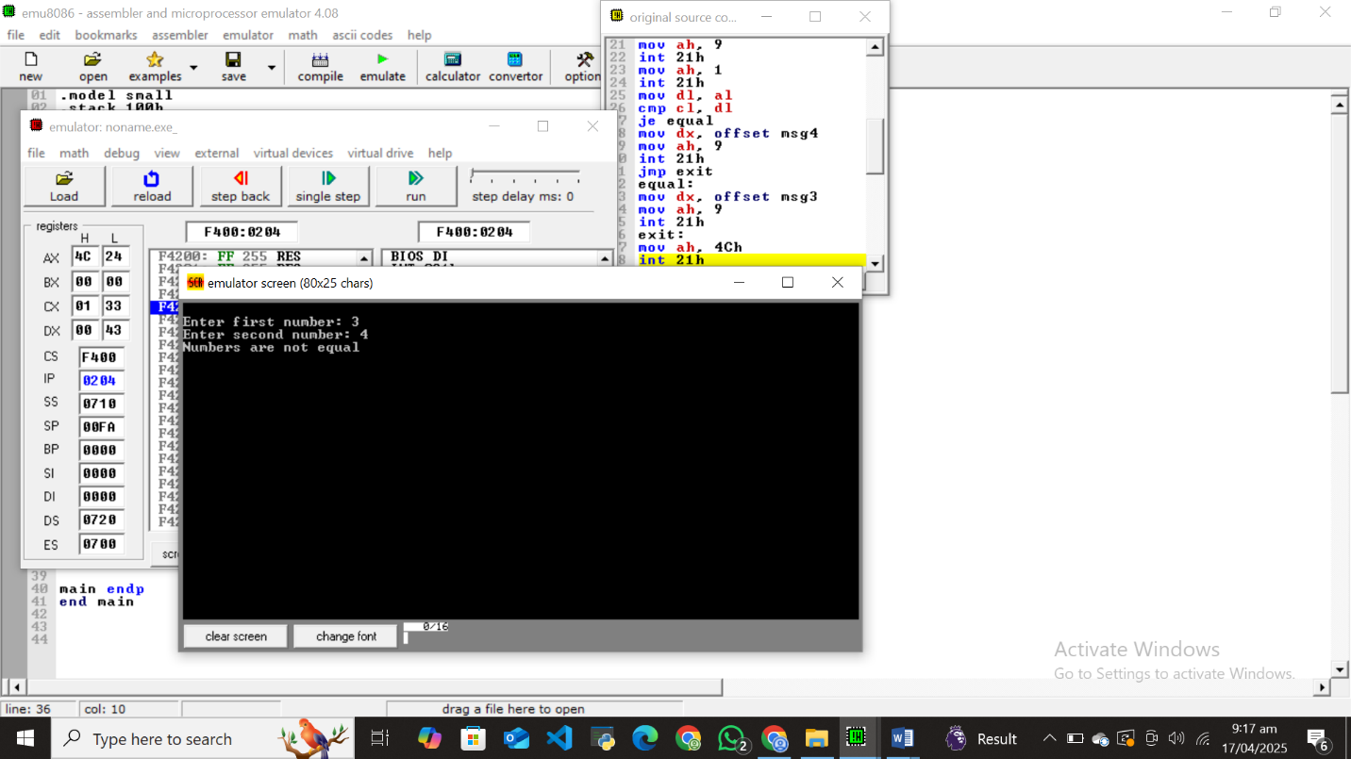

**TASK: 2**

.model small

.stack 100h

.data

msg1 db 10,13, "Enter a number: $"

msg2 db 10,13, "Number is positive: $"

msg3 db 10,13, "Number is negative"

.code

main proc

mov ax, @data

mov ds, ax

mov dx, offset msg1

mov ah, 9

int 21h

mov ah, 1

int 21h

mov bl,al

mov cl,30h

cmp bl,cl

jg positive

jl negative

positive:

mov dx, offset msg2

mov ah, 9

int 21h

mov ah,4ch

int 21h

negative:

mov dx, offset msg2

mov ah, 9

int 21h

mov ah,4ch

int 21h

main endp

end main

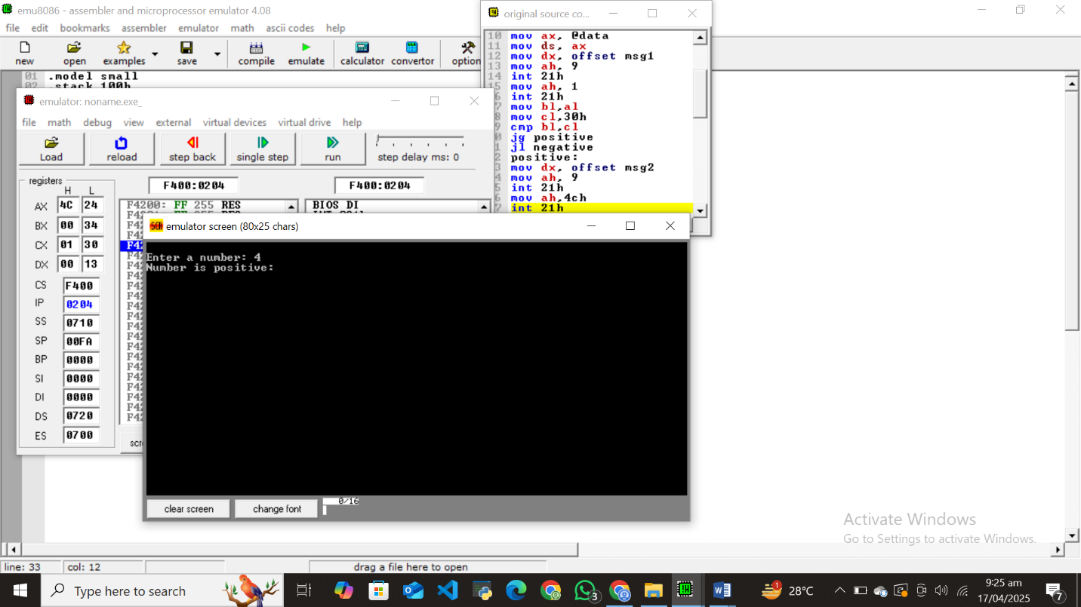

**TASK: 3**

.model small

.stack 100h

.data

msg1 db 10,13, "Enter a number: $"

msg2 db 10,13, "Number is even: $"

msg3 db 10,13, "Number is odd:$"

.code

main proc

mov ax, @data

mov ds, ax

mov dx, offset msg1

mov ah, 9

int 21h

mov ah, 1

int 21h

mov bl,2

div bl

cmp ah,0

je even

mov dx, offset msg3

mov ah, 9

int 21h

mov ah,4ch

int 21h

even:

mov dx, offset msg2

mov ah, 9

int 21h

mov ah,4ch

int 21h

main endp

end main

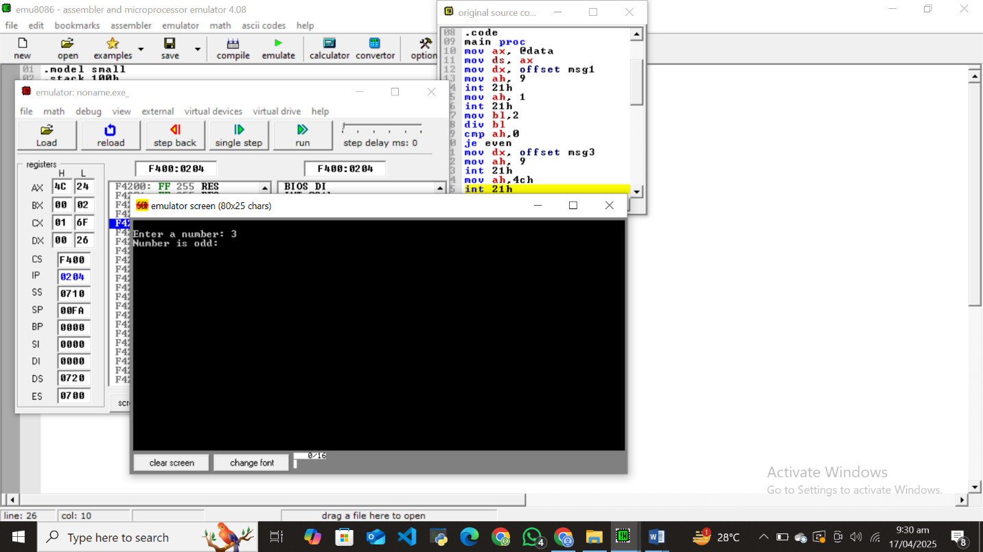

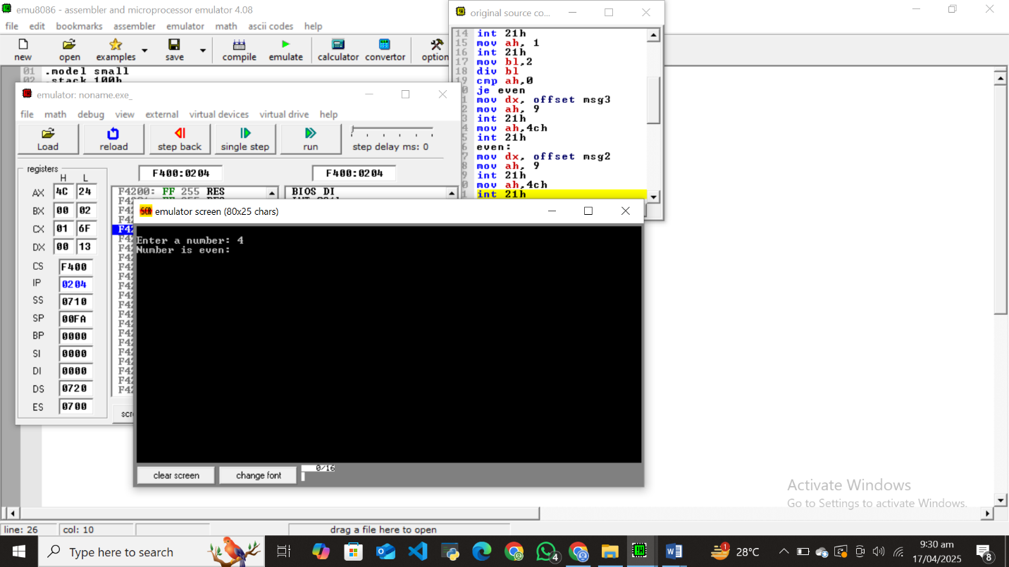

**TASK: 4**

.model small

.stack 100h

.data

msg1 db 10,13, "Need hard work$"

msg2 db 10,13, "Satisfactory$"

msg3 db 10,13, "Enter your marks: $"

.code

main:

mov ax, @data

mov ds, ax

lea dx,msg3

mov ah, 09h

int 21h

mov ah, 01h

int 21h

sub al, '0'

cmp al, 5

jl less_than_5

lea dx, msg2

jmp display

less_than_5:

lea dx, msg1

display:

mov ah, 09h

int 21h

mov ah, 4Ch

int 21h

end main

